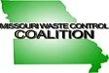

CERTIFICATE OF ATTENDANCE
CLE

I hereby certify that ____________________________________ attended the Missouri Waste Control Coalition Environmental Conference at Margaritaville Lake Resort in Osage Beach, Missouri on July 10 – July 11, 2023.

This conference qualifies for 10.8 hours of continuing legal education in the state of Missouri.
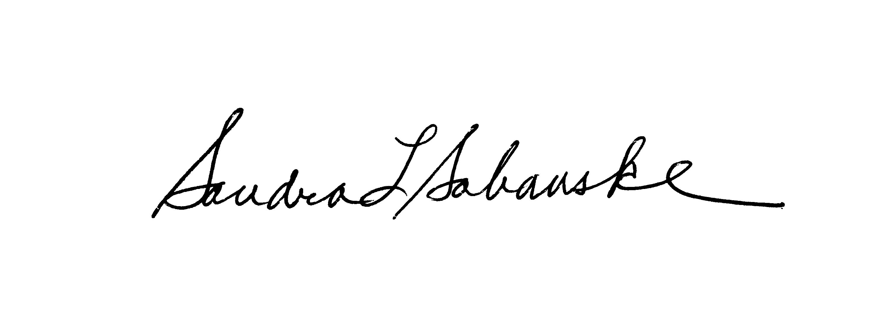
Sandra L. Sabanske
Executive Director

Dated: July 11, 2023

